Directions:

First reading: Read the article about the American Dream. See how the this article relates to the survey in

class. You may write down your comments, but you don’t have to.

Second reading: a. Find the author’s claim and/or the main ideas and highlight green (1 pt)
b. Find three pieces of evidence or examples that support the author's claim and/or the
main ideas and highlight them blue (3 pts)
c. highlight pink any text that is confusing or puzzling (1 pt)
d. highlight yellow information that also important ) (1 pt)

Third Read: Look over the graphic and answer the questions that follow (4 pts)

________________________________________________________________________________________

The new normal poll: Americans care more about the rainbow than the pot of gold
May 17, 2012
Since the economic downturn in 2008, Americans are redefining what success looks like. According to a survey by Solomon McCown & Company and Anderson Robbins Research, eight out of 10 Americans indicate the recession forced them to change the way they looked at life. A happy marriage, a healthy retirement and environmentally responsible living matter 33 percent more to Americans than being successful in a high-paying career.
“Economic status and all the creature comforts it brings are less important in the New Normal,” Ashley McCown, president of Solomon McCown & Company, said in a news release.
In the poll, 24 percent of Americans reported that their household had “mostly recovered” from the impact of the recession; 41 percent said they “still have a ways to go;” and 14 percent said they “might not ever fully recover.” But even a majority — 56 percent — of those who feel they might not ever recover said they have already achieved the American Dream or are on their way to achieving it.
Other key findings from the survey include:
- Home or apartment: 67 percent feel owning a home as part of the American Dream.
- Children or empty nest: 54 percent ranked “having children” important to achieving the American Dream. Married Americans with no children at home were the most likely to feel they have achieved the American Dream.
- Money or time: 51 percent said they preferred more money than more time.

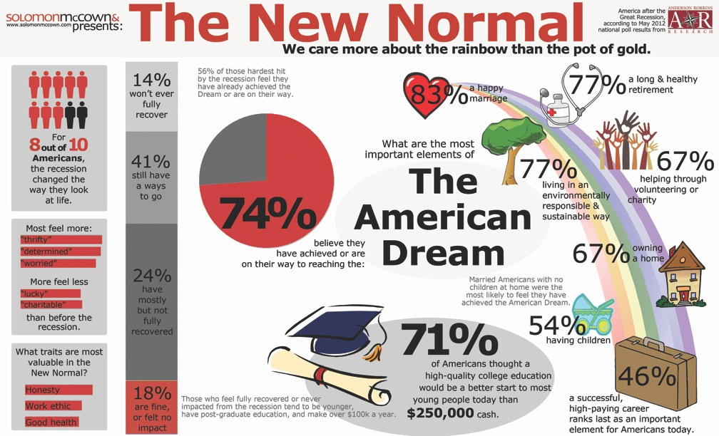
"The New Normal Poll: Americans Care More about the Rainbow than the Pot of Gold." PRSA. The Public Relations Society of America, 17 May 2012. Web. 09 Mar. 2016.

What is “The New Normal”, according to the graphic?

Why is there a rainbow in the picture? What does it represent?

Why might 26% of Americans think they aren’t achieving The American Dream?

Would it be possible to have this dream? Explain why or why not.

