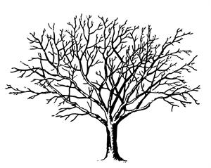

**Possible Arguments:**

**Initial Question:**

**Data Tree**