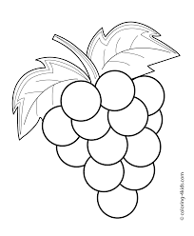
Ranking Character Traits
RL 9.2
Find thirteen traits for Dionysus using chapter 2 either directly from text or from inferences. Decide which trait is his strongest by putting a star * next to the trait. Include textual evidence that helps you justify your decision. Include this at the bottom of the page.

