Part I - Cornell Note-Taking
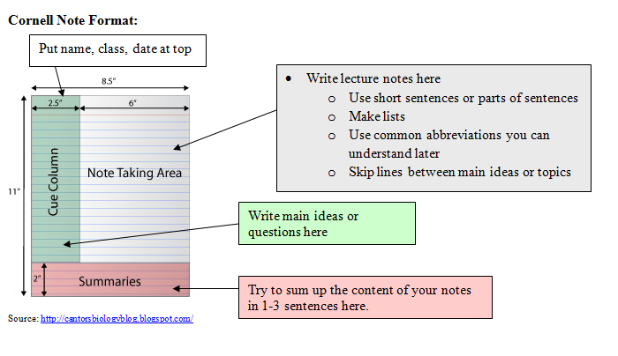
A simple note-taking system is called The Cornell System, which was designed by Walter Pauk, emeritus, at Cornell University. All you will need is standard college-ruled lined paper and the section of your binder for notes. Usually, you will not turn in your notes in our class, but you will need to study them for exams and quizzes. These notes can allow for you to more easily look over information and recall key details for tests if they are used correctly.

#1 Name, Class, Date, and Subject
#2 The note taking area is where you will start to write first. You should not attempt to transcribe every word spoken or written by the instructor. To avoid missing information during the lecture, you should develop a system of abbreviations you understand or similar shorthand that is often used in cell phone text messages, for example. As you take notes, realize that your emphasis should be on the key ideas, rather than the actual words used to convey those ideas. Look for those key ideas in headings, bulleted sections, boldface words – anywhere that looks and sounds more important. The more practice you have at this, the easier it becomes!
#3 The cue column is not created until you review your notes (which, ideally, you do as soon after the lecture as possible, and certainly before the next lecture). As you study the material in your notes, you should devise questions which the notes answer (think "Jeopardy"). These questions are the "cues" that should be written in the cue column. By writing questions, you are forced to think about the lecture material in a way that clarifies meaning, reveals relationships, establishes continuity, strengthens memory, and attempts to predict test and exam items.
#4 The summary should be written after you have finished your cue column. Use your own words in 1-3 sentences by looking at the most important cue words and phrases from the notes.
#5 Review notes at home and before tests by reciting and rewriting information. (tear out this page and put in notes section)
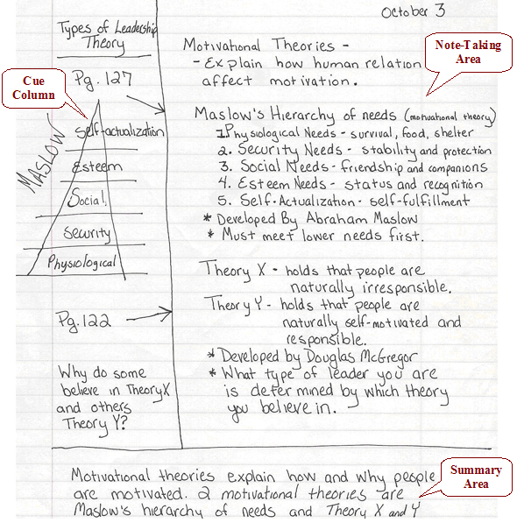
Example of notes for Human Development course:

What systems of abbreviations did the note-taker use to make the note-taking section effective?
How does the cue column help to organize the information?
Why is the question important in the cue column?
Does this summary need more information or less information?
There are three specific things that this paper needs at the top. What are they?

