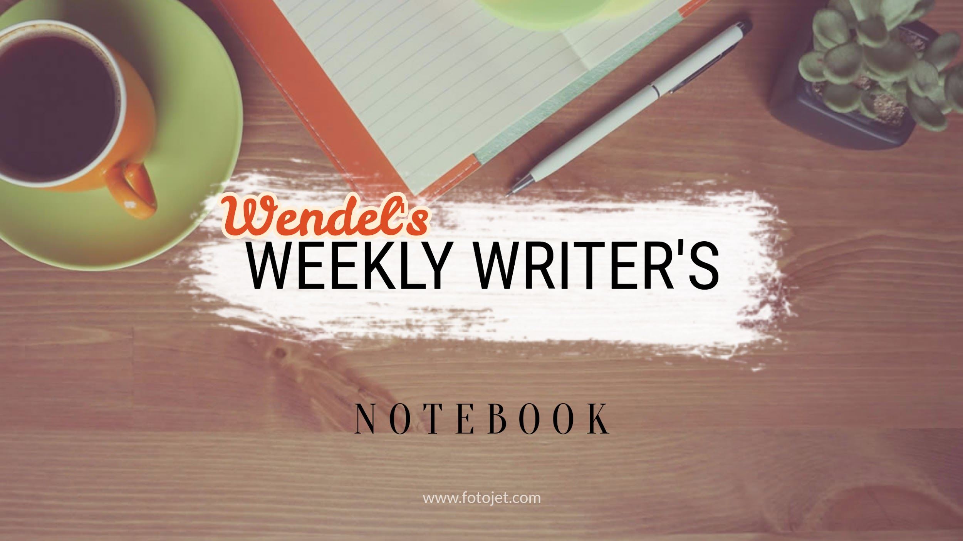
Integrating Textual Evidence

Engage
Wordsworth stated that Romantic poetry was marked by a "spontaneous overflow of powerful feelings" (263).  Romantic poetry is characterized by the "spontaneous overflow of powerful feelings" (Wordsworth 263).  Wordsworth extensively explored the role of emotion in the creative process (263). | What do you notice about how these three sentences integrated textual evidence?  Write down your observations here:  Now, share out loud with your partner

Explore and Explain
Go to:
https://student.unsw.edu.au/paraphrasing-summarising-and-quoting

In your own words, when and why do we

Paraphrase:

Quote:

Summarize:

Emulate
Write like a professional:
Take out your writer’s notebook (yes, actual paper). Make sure to label this “integrating textual evidence.” Using a paragraph from a book you are reading for class, compose one paraphrase, one summary, and one quoted sentence. Be prepared to share this model for class.

Epic Fails
How do writers fail to incorporate evidence correctly? Watch the videos here.

Be sure to record what plagiarism is:

Record what patchwriting is:

Editing Quiz
Take the self-correcting quiz here. Your goal is to get 4/4 correct!

Evaluate
How did this help you improve as a writer? Be specific!

Which assignments will this help you with?

What is still unclear to you?

Share
Click HERE to turn in

